**Compassionate Officer Program (COP)**

**Overview Document**

# Introduction

The world needs better tools to de-escalate situations with people who are challenged by mental or behavioral disorders. For most police departments, the calls involving distressed citizens represent a majority of the calls. For example, San Francisco [has over 50,000 calls a year for various "cases involving a person in a behavioral or mental health crisis"](https://www.sanfranciscopolice.org/your-sfpd/explore-department/crisis-intervention-team-cit). When the police can not de-escalate a distressed citizen, the use of force often exacerbates the situation. Dealing with these kinds of situations is a learned skill, but it can take a large investment of time to train peace officers in nonviolent communication.

This project intends to develop better tools to train police officers to de-escalate situations with people who are challenged by mental or behavioral disorders. Historically, training for de-escalation has been through books and role playing. Instead, this project will use current technologies to build an immersive game-like experience that can train a peace officer in a wide range of de-escalation techniques. The communication techniques that are trained are [based on principles of nonviolent communication](https://en.wikipedia.org/wiki/Nonviolent_Communication). Peace officers will use the principles of nonviolent communication (NVC) and other communication tools to deal with various common situations, such as ‘a domestic disturbance’, ‘suicide attempt’, ... Situations will be based on real-life police body cam data collected during encounters with distressed citizens.

Key advantages of this project:

* Realism - Immersive game experiences, virtual reality 3D, responds to the voice of the officer. Working with virtual training partners has [proven to be effective practice](https://neurosciencenews.com/virtual-human-training-18257/) for real life interactions.
* Known Reliable Communication Tools - NVC tools have proven themselves in the streets and in international mediation as a reliable way to create a connection with another person.
* Street credibility - Scenarios are based on body cam data from the NewYork Police department and decades of experience from former police officers
* Flexibility - Ability to re-skin situations enables sensitivity to gender and racial concerns. E.g. ability to run the same scenario with a black, white, or asian characters.
* Data is the most important key advantage - With training data and real life police performance information, we can develop maps to most effective de-escalation strategies. But in the long term view, we hope to develop a data format that can be used by future generations of data scientists working on [evidence-based policing](https://en.wikipedia.org/wiki/Evidence-based_policing) to create better tools for training peace officers to respect the rights of distressed citizens.

Current team members:

* Thom Bond - Nonviolent Communication Trainer, https://www.thombond.com/
* Anthony Torres, NYPD Detective (ret.), Nonviolent Communication Trainer
* Michael Roberts - Software Engineer

Table of Contents

Introduction 1

Short- and Long-Term Vision of Project 3

Short Term Vision 3

Long-Term Vison 3

Non-Violent Communication is a skillset and a mindset. Games practice the skill sets. 4

Every game is an opportunity to learn. So, log everything. 4

Example training sessions 5

‘Conversational Units’ are the foundation for the basic system. 7

Technical Design 8

Reference Info 8

# Short- and Long-Term Vision of Project

## Short Term Vision

**Customers** – 1st responders and NVC enthusiasts

**Technology** – The first version of the software will be a basic web-based system that is available on computer or mobile device to practice NVC skills. This will be a simple text-based game. Example below.

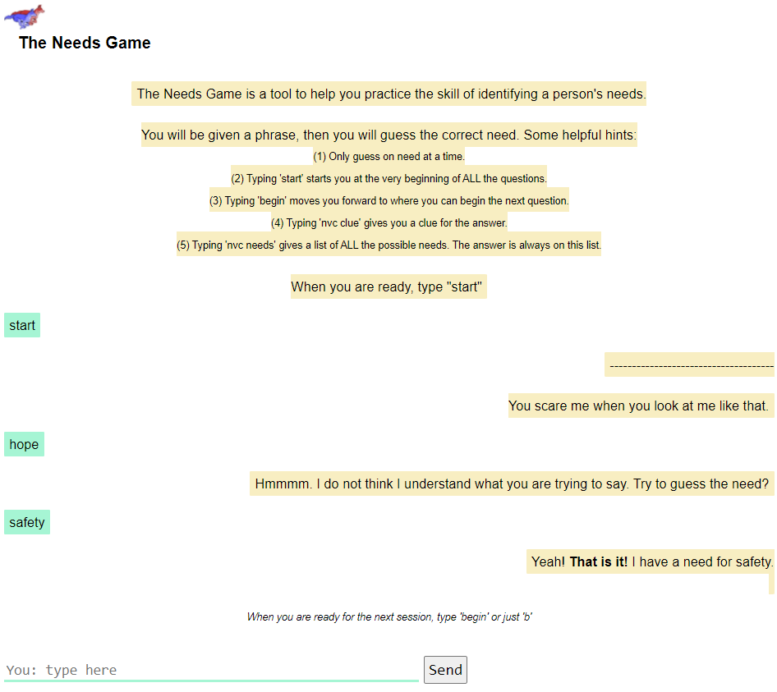

## Long-Term Vison

**Customers** – Once these tools have proven effective, we would like to provide this training to other parts of society. High school principals, hotel managers, bar owners, and many others might all get value from de-escalation training.

**Technology** –

* Better ways of modeling conversations will be explored, such as using AI or chatbot software.
* The long-term goal is to create a virtual reality (think metaverse) experience where a trainee can talk to a character and de-escalate the situation. The trainee will be able to talk and the characters in the system (will convert their voice to text for processing). The characters will respond to the trainee’s input and will escalate or de-escalate the situations.

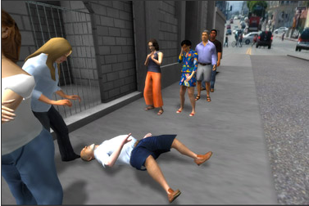

# Non-Violent Communication is a skillset and a mindset. Games practice the skill sets.

Nonviolent communication is a *skillset* and a *mindset*.

* The ***‘skillset’*** contains skills like:
  + An ability to identify of another person’s feelings or needs
  + communicate naturally and gracefully with NVC. (non-violent, non-leading, OFNR,...)
* The ***‘mindset’*** is both
  + a desire for connection and
  + mindfulness, a stable emotional base that provides the foundation of the conversation.

This program is designed to be a tool to help develop skill sets. (It is not clear how it can support the development of the correct mindset at this time.) For the mindset, it is **not** expected for NVC students to try to fake the feeling of connection with the software. However, we do hope that NVC students approach it with curiosity and willingness to role play appropriate to any new game.

**Realistic expectations of scoring a player’s actions:**

* To create a score for the conversation, a student’s responses will be compared against examples. There are common NVC’ish ways to say things and those patterns can be cataloged for scoring. However, there will always be new ways to say something in NVC, that will receive a low score because it does not fit the *current* models well. Developing a large catalog of responses will help mitigate the problem that new responses will be scored poorly.
* Cultural issues will need to be addressed as itis released to different audiences. Even within the United States there are cultural differences, that create communication differences, that might require changes to the persona communication models. For example “y'all’’ (southern) vs ”you guys” (northern). Regional specific models are expected.

# Every game is an opportunity to learn. So, log everything.

* It is understood that the best feedback for improvement for the system will be the errors from things it does not understand. For example, if someone says “I like pizza”, an irrelevant statement, we should be able to see from the logs what the response is and to correct that response in the future. This is even more important when someone uses NVC in a novel way and it gives a poor response. We should be able to take that learning and apply it to future sessions. So, it should have detailed logs that capture everything. These logs can later be mined for data.
* We can also use the data in the logs to improve the scoring. For example, we can ask an NVC professional to interact with software, with all interactions being saved to the logs. Then we can use the logs to model that conversation as being a winning score for future students. Students who have conversations similar to the NVC professional will receive a passing score.

# Example training sessions

Training sessions might model conversations with various type of individuals and situations

Mentally or behaviorally challenged

1. Domestic Disturbance
2. Someone wanting to hurt themselves
3. Schizophrenic
4. Drunk/Drug
5. Autism
6. Depressed - Someone having a bad day

Children

1. Scared lost child
2. Scared mom that lost her child.
3. Child shoplifter

Helping fellow 1st responders

1. A police officer after a life-threatening situation
2. A dispatcher after a tough call

**Detailed Table of Possible Training Personas**

|  |  |  |  |  |
| --- | --- | --- | --- | --- |
| **Group** | **Feelings** | **Needs** | **Persona  Short Story** | **Long Story** |
| Mentally or behaviorally challenged | angry, sad, scared | respect | Domestic Disturbance | Character is yelling “She never stops telling me what to do, She is so annoying. Everyday, you have to tell me your opinion on how I should do everything in my life. It drives me crazy. I can be an adult, you know. I don't need you to to tell me what to do all the time. I'm perfectly fine doing crap by myself. “ |
| Friends & Family | embarrassed | respect, community | Someone wanting to hurt themselves | My home sucks and nobody cares about me at all. Nobody cares if I live or die. The world will probably be better without me…. |
| Friends & Family | frustrated | safety | Schizophrenic | *< insert Schizophrenic speak>* |
| Friends & Family | nervous, scared | integrity, authenticity | Drunk/Drug | “Hey officer, I know what you are doing. You are going to use that nonviolent communication crap on me, again. You always sound so stupid when try to speak giraffe or rhino, whatever furry animal they call it. burp..” |
| Friends & Family | scared, troubled | Safety | Autism | *< insert* Autism *speak>* |
| Friends & Family | upset | autonomy | Depressed - Someone having a bad day | Well, I went to the doctor the other day and found out that I have cancer. And my wife filed for divorce and then ran off with the doctor, taking my car and my dog. I just want to sit here. |
| Child | sad, lonely | connection | Scared lost child | I broke my phone and I don’t have the directions home now. I wanna cry. |
| Fellow 1st responders | Angry,  Scared, hungry | hunger | Child shoplifter | pending |
| Business | unsettled | peace | A police officer after a life threatening situation | pending |
| Business | unsettled | peace | A dispatcher after a tough call | pending |

# ‘Conversational Units’ are the foundation for the basic system.

The first version of the game will use ‘conversational units’ to manage the conversation. In the long term

we may try and combine several approaches to achieve the best training experience.

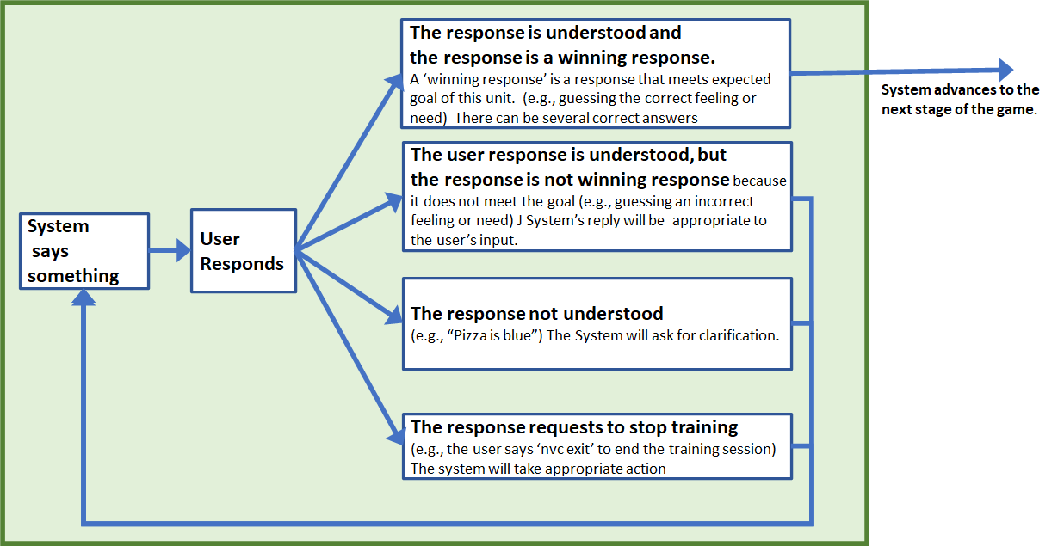

## 

# Technical Design

There is a separate technical design document that goes into detail of the architecture. (See below)

Briefly, the first version of the software will be implemented with a Python/Flask app that is deployed to the Google cloud’s AppEngine to make it available on the internet. Source code for the first version of the ‘Needs Game’ can be found here <https://github.com/MikeRobertsIsHappy/NeedsGameApp>

Phases of development:

|  |  |  |  |  |
| --- | --- | --- | --- | --- |
| Phase | Title | Description | Where | When |
| 1 | Guess the need game. | A simple computer game where the trainee is given a single prompt (e.g. “You’re going bowling again?!?”) and the trainee needs to type the single correct needs as a response. | Normal computer | March |
| 2 | Multi-step conversations | Like above but a more complex version that can allow multiple steps (feelings and needs) in a conversation | Normal computer | May |
| 3 | Simple VR version of game | Like above and create a VR environment where an NPC embodies the conversation | VR | Sept |
| 4 | Complex VR | Create more complex models based on AI or other technology | VR |  |

# Reference Info

**Documents to support this project**

1. ***COP - Overview* *Documen****t* - This document.
2. ***COP – Partnership***– Discusses ways for people to participate in this project
3. ***COP – Technical Design*** *–* This will discuss the technical architecture and directions
   * *Partial, still in development*
4. ***COP – How to Create a Scenario*** – Discusses how to create a scenario for the first version of the text-based game.
   * *Partial, Still in development*

**A recent paper**

*The Deafening Demand for De-escalation Training: A systematic Review and Call for Evidence in Police Use of Force Training* by Robin S. Engel, Hanne D McManus, Tamera D. Herold

<https://www.theiacp.org/sites/default/files/IACP_UC_De-escalation%20Systematic%20Review.pdf>

# Directions of Project

This project can evolve several directions.

Simple Standalone Games

Computer based training

The Needs Guessing Game

The Feeling Guessing Game

Situational games appropriate to public

Generalized computer-based training for NVC skills

Situational games appropriate to first responders’ dialog

Mobile/ Phone implementations of games

VR training environments

VR Game

Phone games